Method 1:Setting up static IP manually
When setting up your IP address you need to know what network interface cards are on your machine. You can find out the interface names of the cards on your machine with the following command:
ip addr
This will list the interface names of all the NICs on your computer, such as eth0 (hardwired NIC), lo (loopback interface for the localhost), and names for your wireless card (wlan0 or wifi0).
You may also use command:
ifconfig -a
to list all interfaces which are currently available, even if they are down.

If you just want to configure the IP address for an interface card temporarily, you can use command:
ifconfig <interface name> <ip address>, such as:
ifconfig eth0 192.168.1.100
However, IP address configured with command ifconfig will be forgotten after restart. To configure IP address for a interface permanently you’ll need to edit the /etc/network/interfaces file:
sudo vi /etc/network/interfaces
By default the lo or eth0 network interface is set to use DHCP to obtain the IP address automatically:

# The primary network interface
auto lo
iface lo inet dhcp
To configure the network interface to use a static IP address, edit the interfaces file and add the lines listed below:

# The primary network interface
auto eth0
iface eth0 inet static
address 192.168.1.100
gateway 192.168.1.2
netmask 255.255.255.0
network 192.168.1.0
broadcast 192.168.1.255
dns-nameservers 192.168.1.1 8.8.8.8

However, keep in mind, the IP addresses for your gateway and dns-nameservers CANNOT be set with random IP addresses. They must be the correct IP addresses of your current configuration. Otherwise, your machine will lose network connection. You may find these information through checking the DHCP server settings.
Save the file and restart your networking services to make the configurations take effect:
sudo service networking restart
or
sudo /etc/init.d/networking restart, depending on which Linux distribution you're using.
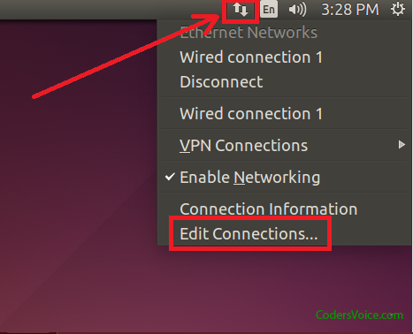
Method 2: Setting up static IP through GUI
A more convenient way to set up static IP may be through the configuration GUI, take Ubuntu 14.04 LTS for an example:
Click the network icon on the upper right corner of the window and click the Edit Connections... option in the dropdown list.

Select the Wired Connection 1

click Edit
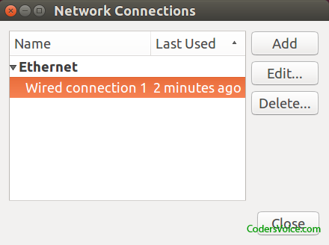

Click the tab IPv4 Settings, and take changes to the Addresses section,
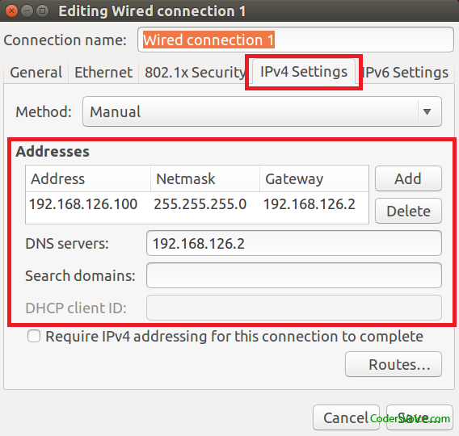

Click Save, Ubuntu will apply the changes automatically the first time you make the changes.
Use ifconfig to check the new address takes effect,
